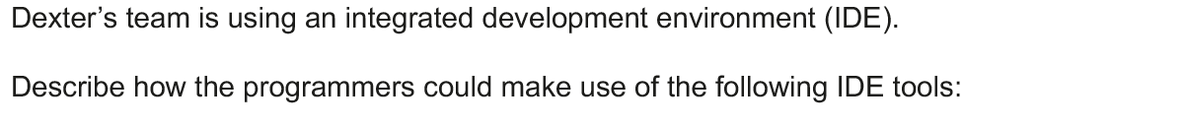
Breakpoints: A breakpoint is a point in code where the program will stop being executed. Breakpoints can be added to code to allow programmers to examine the values stored inside the variables (By using a watch window)
Stepping: Stepping is a processes of running a program line by line. This allows people to see how variables change as the program runs.
A programmer will use an IDE to debug his program during development.
Describe three features of an IDE that help debug the program. Do not include Breakpoints or Stepping [6]
1. Syntax error highlighting
2. Crash Dumps to see the values of variables when the program crashes
3.

